Bowel Diary

Name: ________________________ Please complete diary for: 3 days/1 week/ until next appointment

Date | Time  AM/PM | Strain Y/N | Incomplete Emptying  Y/N | Pain  Rate: 0-10  0 = no pain  10 = worst possible pain | Abdominal Bloating  Rate: 0-10  0 = no bloating  10 = worst possible bloating | Use of fingers  to assist Y/N | Time Taken | Form  Type 1-7  (refer to  image at  end of document) | Bowel agent taken + amount  (tsp or grams)  E.g. GOS, Psyllium – how much? | Urgency/  Accidents | Anxiety  (The worst  anxiety you  felt today)  Rate: 0-10  0 = no anxiety  10 = worst imaginable anxiety
Bowel Diary

Name: __________________ Please complete diary for: 3 days/1 week/ until next appointment

Date | Time  AM/PM | Strain Y/N | Incomplete Emptying  Y/N | Pain  Rate: 0-10  0 = no pain  10 = worst possible pain | Abdominal Bloating  Rate: 0-10  0 = no bloating  10 = worst possible bloating | Use of fingers  to assist Y/N | Time Taken | Form  Type 1-7  (refer to  image at  end of document) | Bowel agent taken + amount  (tsp or grams)  E.g. GOS, Psyllium – how much? | Urgency/  Accidents | Anxiety  (The worst  anxiety you  felt today)  Rate: 0-10  0 = no anxiety  10 = worst imaginable anxiety

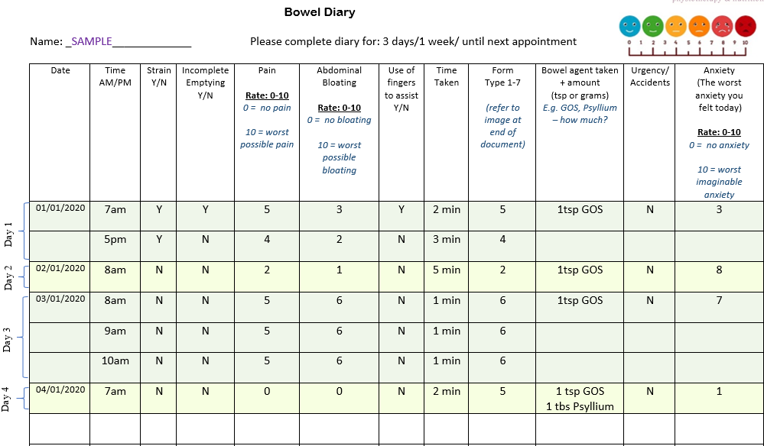

Example

